GD Script:

extends CharacterBody2D

const SPEED = 3000.0
const JUMP_VELOCITY = -4000.0

var health = 100
var player_name = "Kuya Kim"
var level = 67

func _ready():
print(player_name, "has entered with the scene with ", health, "HP.")
take_damage(12)
player_level()

func take_damage(amount):
health -= amount
print(player_name, " Health is now:", health)
func player_level():
print(player_name, " is now entering leve ", level)

func _physics_process(delta: float) -> void:
# Add the gravity.
if not is_on_floor():
velocity += get_gravity() * delta

# Handle jump.
if Input.is_action_just_pressed("ui_accept") and is_on_floor():
velocity.y = JUMP_VELOCITY

# Get the input direction and handle the movement/deceleration.
# As good practice, you should replace UI actions with custom gameplay actions.
var direction := Input.get_axis("ui_left", "ui_right")
if direction:
velocity.x = direction * SPEED
else:
velocity.x = move_toward(velocity.x, 0, SPEED)

move_and_slide()

Output:
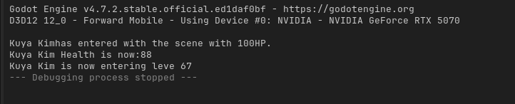

Reflection: I have realized that using godot engine is kinda confusing and it needs a lot of logical thinking in order to come up with a working GD script. For now, I really need to explore more this engine so that I will be able to help my groupmates when the come.

